The History Of Astronomy

# How did it start? What did our ancestors see?

1. It is important to visualize the universe “as it is”. We cannot form a hypothesis about the universe without visualizing it in its raw form. For example, Aristotle in his time put forth a statement that projectiles always moved in straight lines, until their ‘impetus’ ran out , and then they fall on the ground.
2. But we now know that this is not how projectiles work. So why was Aristotle mistaken. It was because he had made his hypothesis without any data or observation of the situation ‘as it is’. But, during the period of renaissance people actually started seeing projectile motion carefully by observing the cannons that were fired. And this led to a far more logical and believable theory about the projectile motion.
3. It was Galileo who reasoned that a projectile shot from a cannon is not influenced by only one motion, but by two -- the motion that acts vertically is the force of gravity, and this pulls the projectile down by the times-squared law. But while gravity is pulling the object down, the projectile is also moving forward, horizontally at the same time. And this horizontal motion is uniform and constant according to his principle of inertia. But could he demonstrate this? In fact, by using his inclined plane again, Galileo was indeed able to demonstrate that a projectile is subject to two independent motions, and these combine to provide a precise sort of mathematical curve.

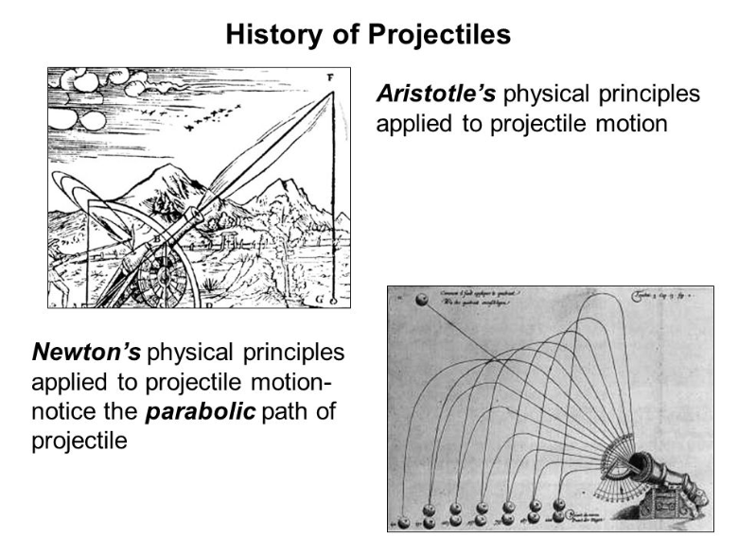

1. But before Galileo there was someone who correctly potrayed the trajectory of projectile motion using only his observation and nothing more. His name was Leonardo di ser Piero Vinci!!!

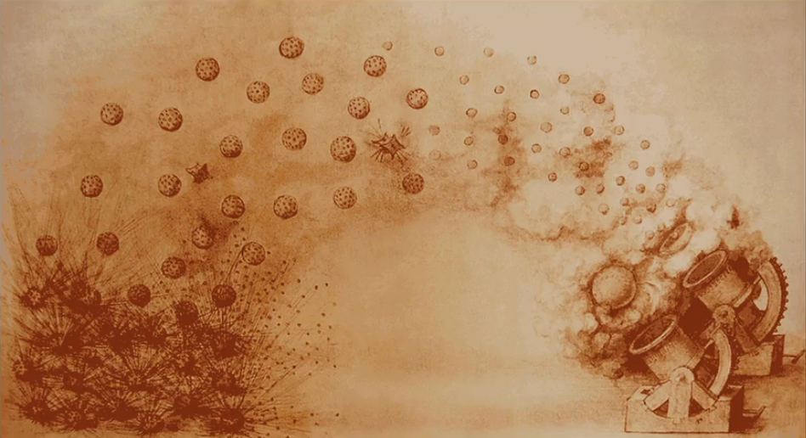

1. One of the basic ways to study the universe, nature or anything is to first develop a hypothesis and then test it against the nature. At the same time, it must be noted that more than one hypothesis can explain the same set of data.
2. One of the basic aspects of studying science is through imagination. Because imagination has the power to take us to places that have yet not been visited with the help of modern technology.
3. Isaac Newton produced a famous diagram which shows a cannon placed on the top of a tall mountain. The cannon is pointing sideways and it fires a cannonball at increasing speeds. As the muzzle velocity increases, the cannonball falls in a parabolic trajectory, explained by his theory of gravity. But Newton realized, that if the atmosphere was thin and so, not slowing down the cannonball. In other words, so, there was no friction force. And if you increase the speed of the cannonball. There would be a speed at which the cannonball was falling at the same rate that the Earth was curving down under it. And that's the imagination of an orbit. And the speed you get from that calculation and his theory, is the orbital speed. And we just needed the technology to accelerate any object to that speed, which would not happen for over 300 years. But Newton was imagining space travel!!!

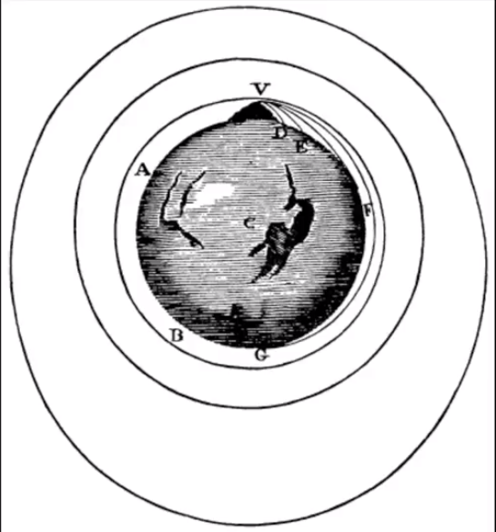

1. Ancient people had the love for astronomy built into their DNA. They learned about the space by watching the sky and making hypothesis accordingly. It is surprising to know that ancient civilisations used astronomy to predict crop cycles, weather, lunar cycle, seasonal cycle and also the pregnancy cycle!
2. Ancient civilisation used astronomy for serving as a guide during travels. As during the day there was no moon and the day was very hot(40-45*C), these travellers usually travelled at the night as then the temperature was cool and they had the moon and stars to guide them.
3. The following picture shows the pattern of the sky that was used by us to make valuable hypothesis about space:

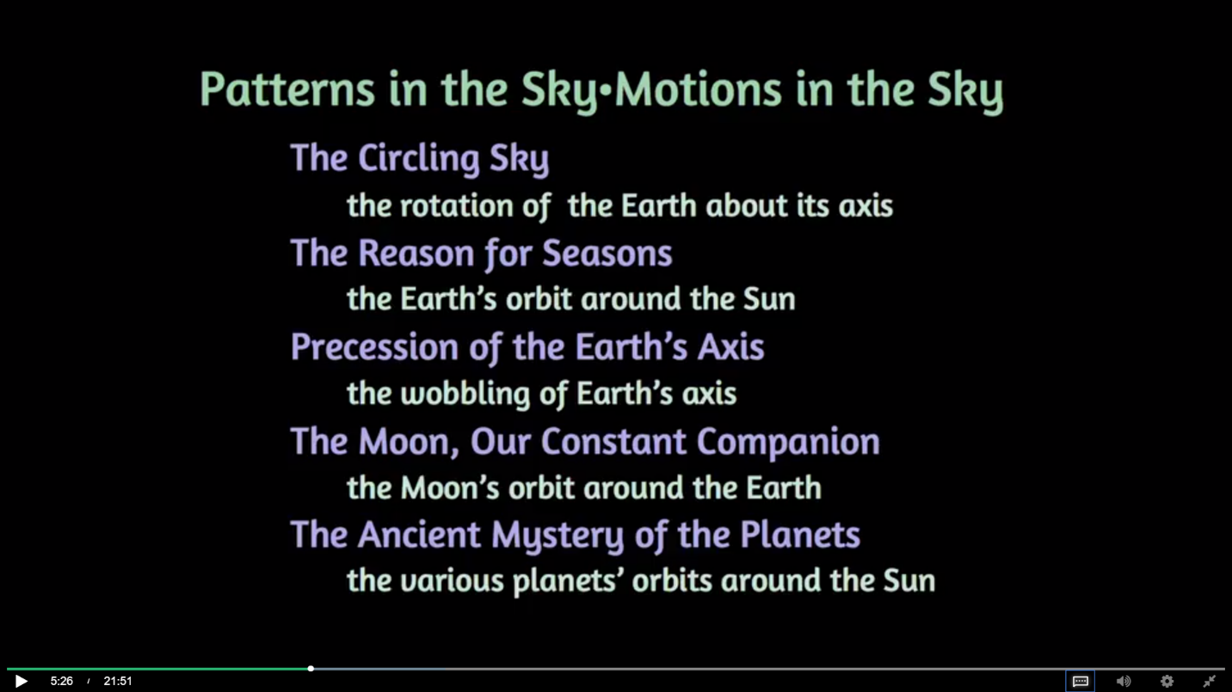

1. The modern day calendar as extensively used astronomy, such as;

* Rotation of earth around its axis – Day
* Revolution of earth around the sun – Year
* Position of phases of moon in the sky/Lunar cycle – Month

1. Ancient civilisation have used the Sun to direct them time. The following picture is called a Genoma, it was used to tell time by analysing the shadow of the stick on the structure:

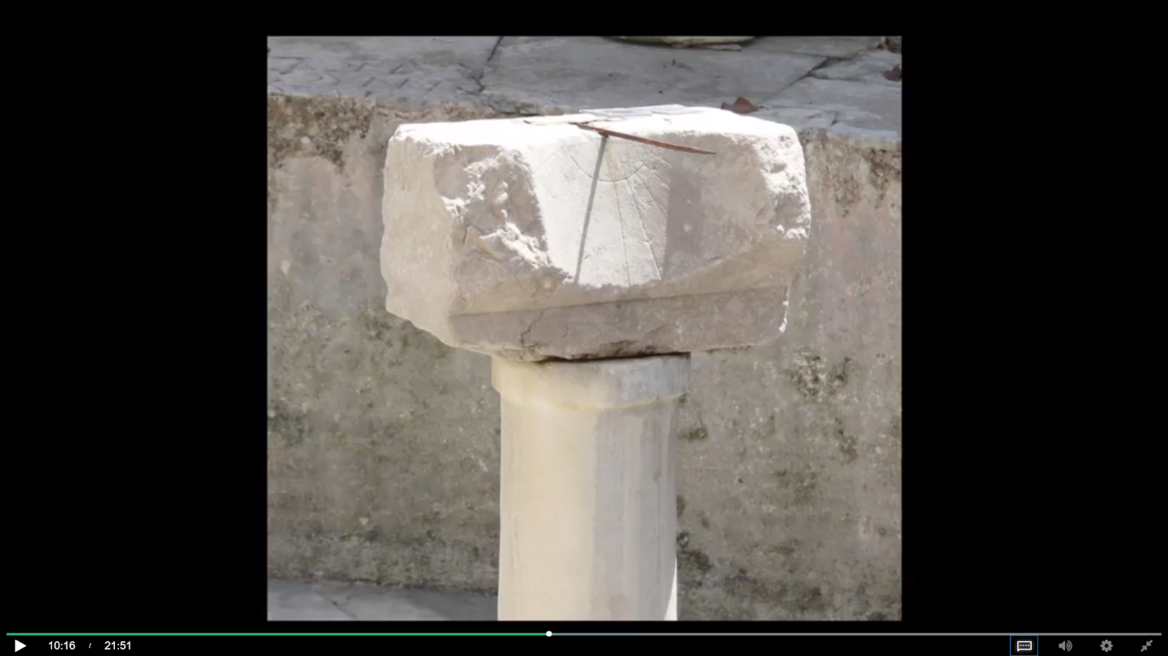

1. Another spectacular specimen of use of astronomy to tell time is The Stonehenge. These stone pillars are on the Salisbury plain with no towns or forests nearby. The largest pillar weighs about 150 tons. Remarkably, the culture that built this imported these stones from as much as 500 miles away. Still, there is speculation as to why and how they brought the stones from so far away. And why they positioned Stonehenge exactly where it was. It was perhaps an astronomical reason.

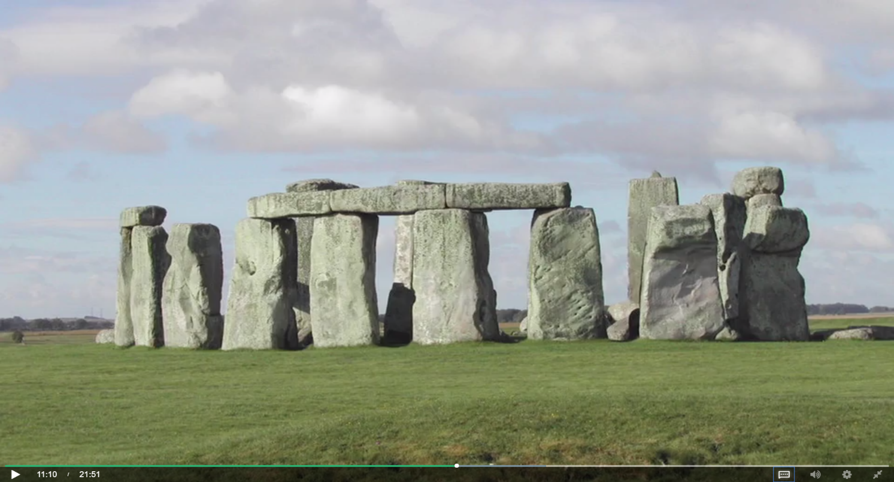

1. On further investigations, it had been found that these alignment of pillars represents an exquisite calendar, that also precisely predicts eclipses!

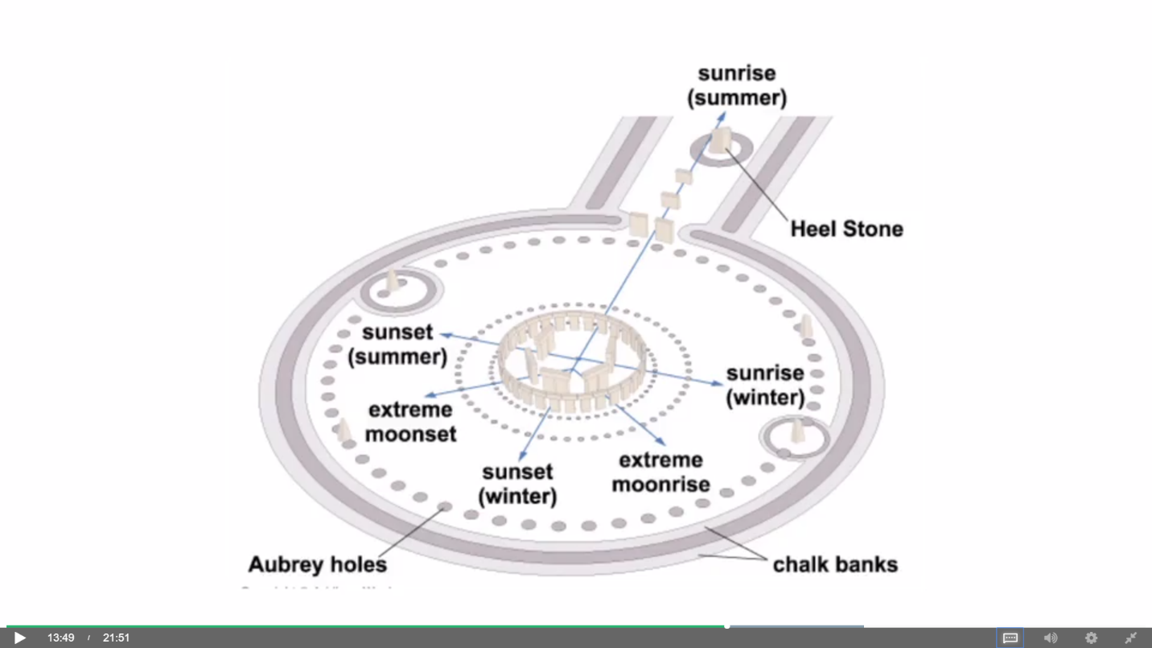

1. A cultural relic called the Nebra sky disk was found somewhere in Bavaria a few decades ago. It almost certainly represents the burial Artifact from a very high cast chief in the Olympic times. And it's engraved with star patterns and constellations, and it was a ceremonial object:

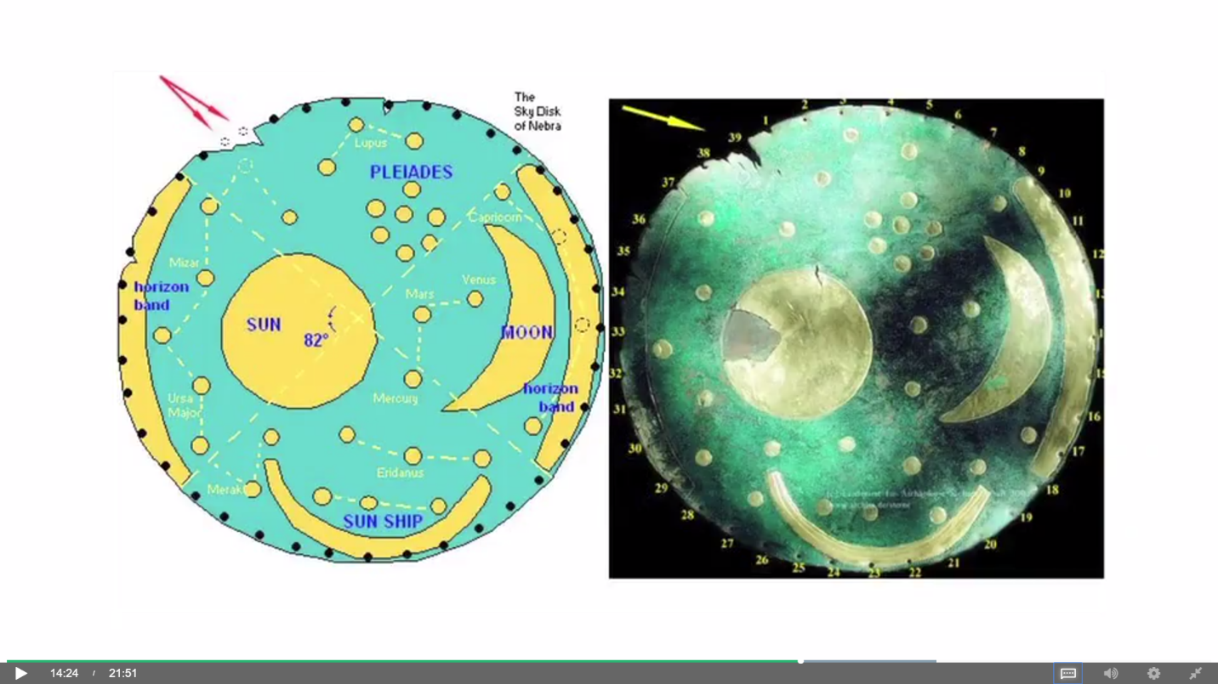

1. The Caracol Chichen Itza has the appearance of an observatory, but that's misleading, there was no telescope here, it was built over a millennium ago by the Mayans. The Mayans celebrated Venus as the primordial object of their sky, and they actually set their calendar according to serious observations of Venus over the year and this building was used for sighting Venus. This was very high status work. The astronomers at the Mayan court were held in high esteem, and the entire culture pivoted around these observations of Venus in this observatory, at one of their main ceremonial sites.
2. A few decades ago, an artifact was found in the Aegean Sea off the coast of Greece, which puzzled archaeologists. The ship had actually gone down two millennia ago, and the artifact that was found, crusted with mud, and rusted and compressed by time, seemed to be a mechanical object. Since its use has been understood in the last decade, it's become known as the Mona Lisa of mechanical objects. It's in fact an analog computer that codifies in an incredible way the observations of the night sky. It's called the Antikythera mechanism. This one object has rewritten the books on the history of engineering. Built this length of time ago, from brass and other materials, it includes off centred gears, and its moving dials on its face codify the positions of the planets including the outermost planets, including their non circular motions, now this is striking and controversial because it was assumed that the eccentric or the non-circular motions of planets were not discovered until the time of Kepler. But the Antikythera mechanism uses eccentric gears to show that Mars, Jupiter, and Saturn, move at a non-uniform rate in the sky. This is also an eclipse predictor, predicting eclipses over time scales of up to 80 years. It's a show piece device that was probably being carried across the in a trading route to trade for other devices or to show how impressive the Greek culture of the time was!

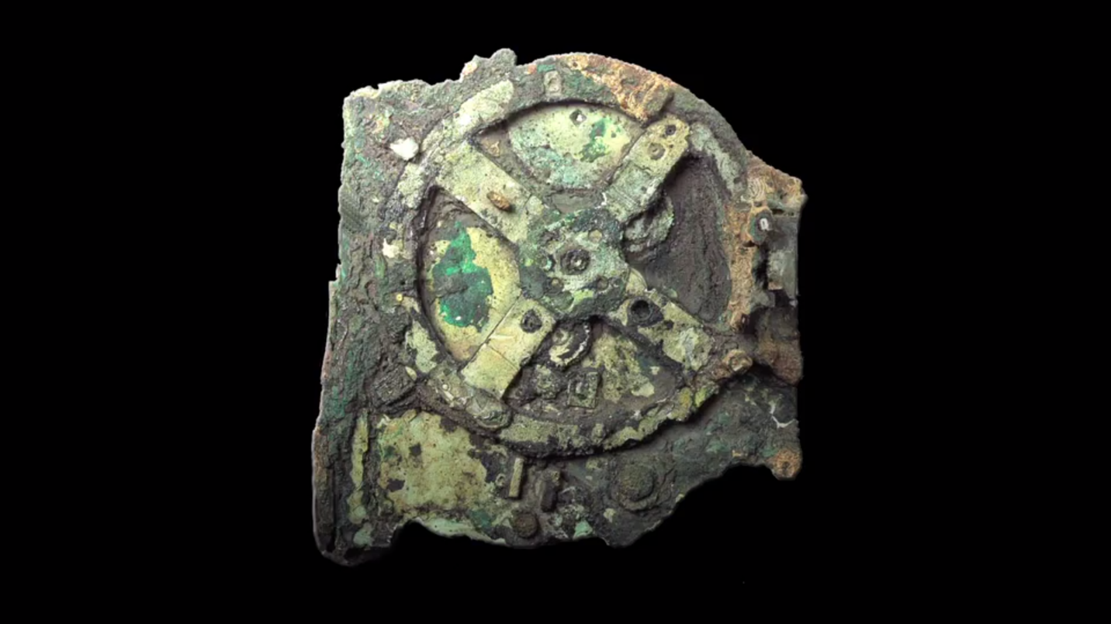

1. It must be noted here that astronomy is not just a science but a convergence of logic and imagination. And a very path breaking statement in this field was made by Greek philosopher Epicurus in around 300 B.C. which opened an entire new area to explore for the generation to come. He said;

*“There are infinite worlds, both like and unlike this world of ours…..*

*We must believe that in all worlds there are living creatures and plants and other things we see in this world.”*

1. This imaginative statement which was then introduced has taken a manifold diverse expansion in the 21st century. Today this statement is one of the most important question that has not yet been answered. Many comic books have also used this concept of ‘multiple earths and universes’ to write their stories and fictions.

1. The reasons why Ancient Greeks and Ancient Indians were prominent in the field of astronomy and science in because they always had a mental image of the things that they saw. Other cultures and civilisation saw the things as they were and made hypothesis and conclusion based on that. Whereas Ancient Greeks and Ancient Indians processed the visual data with logic and mathematics.

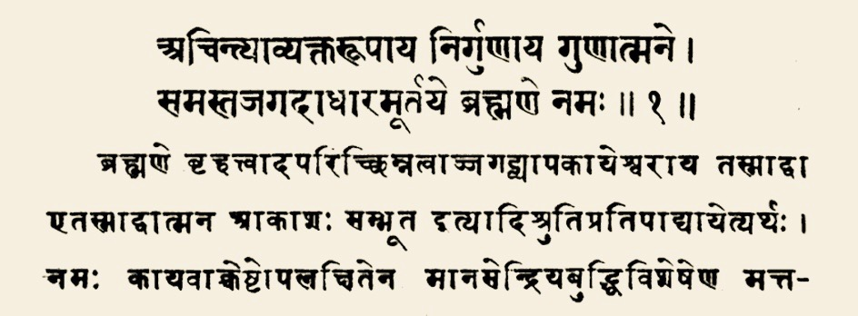

1. Along with Ancient Greeks, Indians also had their own contrasted Sun Dials. One of the greatest Indian mathematician and astronomer of all time known as Aryabhata was the first person who introduced the number ZERO(0) to the world. Without him the modern science would not have even existed.
2. The Indian book known as the Vedas has in it the very nature of the universe written in it. All of the modern question that have emerged in the 20th and the 21st century are already mention in The Vedas which was written around 1500 BCE!
3. Calendar in a topic that relates ancient and modern astronomy. Among the calendar durations, week is the only duration which is not astronomical. This is why many civilisations over time have changed the duration of a week. There have been civilisations where 1 week = 4 days and also civilisations where 1 week = 10 days.
4. The roots of duration of 1 week can be traced back to the romantic era of the Babylonians. They have grouped the number 7 as 1 week because the names of the week in those languages(French, Spanish, Italian, Portuguese) are the 7 moving object in the night and daytime sky; The Sun, The Moon, Mars, Mercury, Jupiter, Venus, Saturn.

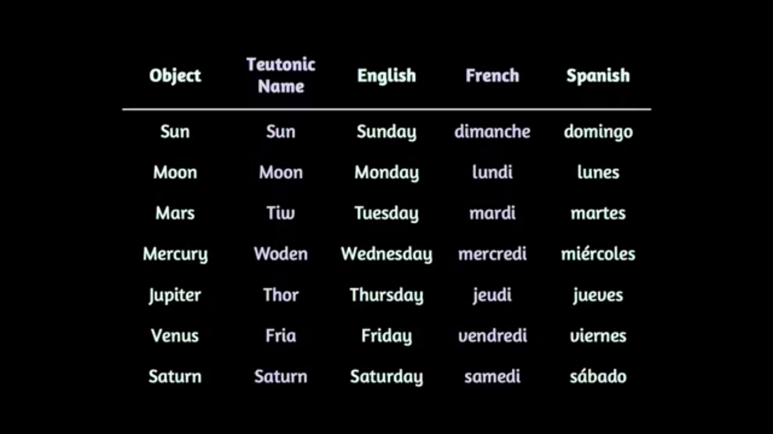

1. But this was not just that easy. Now the debate was that which month should be the beginning of the year. The Romans choose March as they were following the lunar calendar(in 7th century B.C.) and because at that time the snow melted in Rome enough for them to raise an army and go off to do battle and hence limited the time of 1 year = 10 months!
2. This is why the last four months of our year are named after the Roman words for *seven, eight, nine* and *ten.* This calendar fulfilled the needs for few centuries but then the emperor named Priscus and some other emperors decided to pad it out with a *legitimate lunar calendar.* This lunar calendar had 2 light months at the beginning followed by 10 regular sized months. But this is not a very efficient calendar. So now comes the **Solar Calendar!**
3. One complete cycle of a lunar calendar is 11 days and a bit longer than a lunar calendar. Also the lunar calendar is no good for agriculture as it end out in 11 months. Therefore the roman decided to switch to a solar calendar and it met its crop needs. As a relic however, February is the short month, the unlucky month. The month when bad luck happens. And that continues to this day, February is still our short month.  They still had a pretty strictly alternating sequence of 30 and 31 days amongst the later months. They also had a front and a back end of the year. The last months of the year are named after numbers and the first months of the year named after the primordial gods. Some of these gods such as Maya, which gives us the name for May, are found worldwide and were not simply Roman gods Others, such as Janus for January, the God of Doorways and Beginnings, we can see the two faced god in archways in ancient Rome, you can visit them these days, were particular to the Roman culture.
4. Julius Caesar presided over one the most extensive and powerful regimes ever known in the world history. Regulating an empire this large required messages to be passed around thousands of miles, communications, synchronization of military movements, and the movement of goods and services. It could not be done without a good calendar. And so we have the Julian calendar, the first revolution in calendars where Caesar adds a leap year, that is, an extra day every fourth year. Giving a calendar with a mean length of 365.25 days, and that's close to a solar cycle.
5. However, the exact time that it takes for the earth to go around the sun is one hundredth of a day different from 365.25. It's actually 365.24199. That difference is trivial, and from one year to the next is truly trivial. But of course, it adds up. So the Julian's calendar started to get out of synch by a hundredth of a day per year. After a century that's a day, and by Medieval times the Julian calendar was off by a week or so, and agricultural planting cycles were starting to be affected. And so in the era of the great Popes of the Italian Renaissance, we have the Gregorian calendar, the last adjustment made to the modern calendar by Pope Gregory. Pope Gregory recognized the problem with the calendar, he had court astronomers making careful measurements of the length of the day in a year. And so he made a final adjustment, which is built into out calendars, although we rarely have to think about it, where the leap year is skipped in years divisible by 400. And that tweaks the average length of the calendar to very close to the true time it takes the Earth to go around the Sun. The Gregorian calendar is basically only off by less than a ten thousandth of a day per year, and therefore will be good for tens of millennia. **This is the calendar we live with.**
6. Let us now look at some belief and rituals of certain countries abased on the recurrence events on a specific moment marked in the calendar. Look at flags of the world, and you'll notice two kinds of flags. Several dozen countries have a crescent moon in their flags. And even if you don't know what those countries are, those are the Islamic countries. Every Islamic country keeps time by the moon in the way that ancient people have done since the dawn of time. And that schism, perhaps, is some subtext behind the modern cultural dissonance between the East and the w\West. We can understand this, because in the Islamic countries mostly of the Middle East, timekeeping depended on the moon. The seasonal cycle is not as obvious. For example, in Egypt, the seasons are based on the flooding of the Nile, and not on any temperature variations throughout the year. So, these cultures of the Middle East chose to keep a lunar calendar.
7. The word moon comes from the Greek word metron, to measure. And in Islamic culture, the festival days for instance, of Ramadan are only declared when a messi, or high standing observes the crescent moon to declare that appropriate lunar cycle. And so the crescent moon in an Islamic country's flag represents the festival day, or the time keeping that's triggered directly by observation of the moon. Now in principle, if the moon was not observed on the appropriate day due to dust or clouds, which are rare in that part of the world, the festival would not be called, the faithful would not go to Mecca. But the weather is usually good and the festival is cold. But we can see that because these Islamic countries follow a lunar calendar, their calendar shifts by 11 days every year. Which means it shifts entirely through our calendar every 33 years. So it is quite hard for us to look at our calendar and predict when Ramadan is, or any of the Islamic festivals.
8. Another thing we haven't addressed is the finer divisions of time within the day, the month and the year. We're talking now of hours, minutes and seconds. These are also relics going back thousands of years. The division of the day into hours, originally just 12 at night and then 12 in the day, goes back to Egyptian timekeeping practices. The astronomers of the Egyptian court of the pharaohs, 4 and 5,000 years ago, used to use timekeeping stars called decans to mark the sky. And typically, although it's not a fixed pattern, about 12 of these stars would be visible tracking across the sky that they would node. So, they divided the night time sky into 12 sectors and then they followed that practice in the day. So, we get hours from the Egyptians. The division of time within that, of 60 minutes and an hour and 60 seconds and a minute, he's even more ancient going back to the Babylonians, 4 or 5,000 years ago.
9. The Babylonians used a base 60 counting system, unlike our decimal system. It's not clear why they came up with a base 60 counting system, but it's clearly tethered in astronomy. Because typically the sun, or the movement of the Earth around the sun subtends an angle of one degree each day, and 60 is a divisor of 360. So there's good evidence that our divisions both of angle and time, related through astronomy, relate back to the Babylonians.
10. Another question that arises in the measurement of time is that **Why clocks go clockwise and not in the other way.** And that is a simple reference to sun worship. In northern latitudes with the slanting angle of the sun it appears to move clockwise in the northern sky, rising and setting. And so the clock face is just a mirroring of the sun's motion. We can imagine if the world's dominant cultures had emerged in the southern hemisphere, clocks would go the other way around.
11. **Nicolas Copernicus** was the 1st person to come up with the heliocentric model in cosmology. By proposing this model, he said that the earth was not the centre of the universe, but was moving round the sun along with the other planets. This time in history is so important that today we call it as the **Copernican Revolution.**

* Copernicus inherited the ideas of Ptolemy from the ancient world. But he was aware of problems in the Ptolemaic model. It was ugly, clumsy, kludgy, and unnecessarily complicated. He was aware of the retrograde motion of Mars, Jupiter, and Saturn, and realized that if instead of the Earth being at the centre, the Sun was at the centre, those retrograde motions would go away and be naturally explained.
* So, he was motivated to think in terms of the sun as the centre of the solar system. He was also aware of simple Greek geometric arguments that made that same case. And the heliocentric model's problem was the fact that the stars don't vary their brightness in relative positions as the Earth goes round the sun. Why is this a problem? Well, in the geocentric model all the planets, and all the stars, being on a fixed crystalline sphere at the same distance from the Earth, and never varied that distance over a year. So, naturally those stars will always have the same brightness regardless of the time of year. And they won't vary in their relative positions. But if you think about the earth in motion around the sun relative to more distance stars, then there must be times in the year when the earth is farther and closer to a particular set of stars. Giving to effects, those stars should appear brighter on faint to over the course of year and probably more observable. The angles between them, subtended by the Earth, should vary smoothly, growing larger and smaller over the course of a year.

1. This era was also famous for one more historical event. It was the first time when a proper institutional space observatory was ever built by a man named **Tycho Brahe.** In his observatory Brahe made observations and calculations. And later he showed the irregularities in the Moon's orbit and discovered a new star in the Cassiopeia formation. Brahe invented many instruments such as the Tychonian Quadrant which were widely copied and led to the invention of improved observational equipment. *In 1600, Tyco Brahe hired Johannes Kepler as his assistant, who went on to be one of the esteemed scientist of his time!*
2. The Copernican Revolution was an astronomical revolution. A replacement of the geocentric model where the earth is the centre of creation and immobile and everything goes around us, with a heliocentric model where the universe has to be much larger and the earth is in motion. But it's more than a scientific revolution, it's a cultural revolution, because it breaks the cosy pact between humans and their creator. Thereby leading to conflict between Copernicus and the Catholic Church.
3. Kepler had a very hard life, he was constantly ill, his body was covered in boils and the society identified his mother as a cunning witch. So every now and then, Kepler had to put everything he got to save his mother from execution and the left over resources on his health. Tycho Brahe was probably the best thing that ever happened to him. **Working with Brahe, Kepler published his 3 laws of planetary motion:**

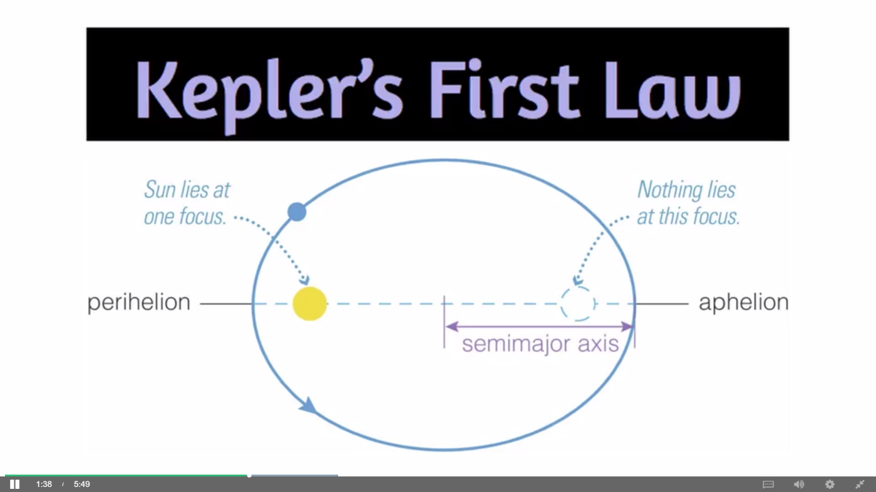

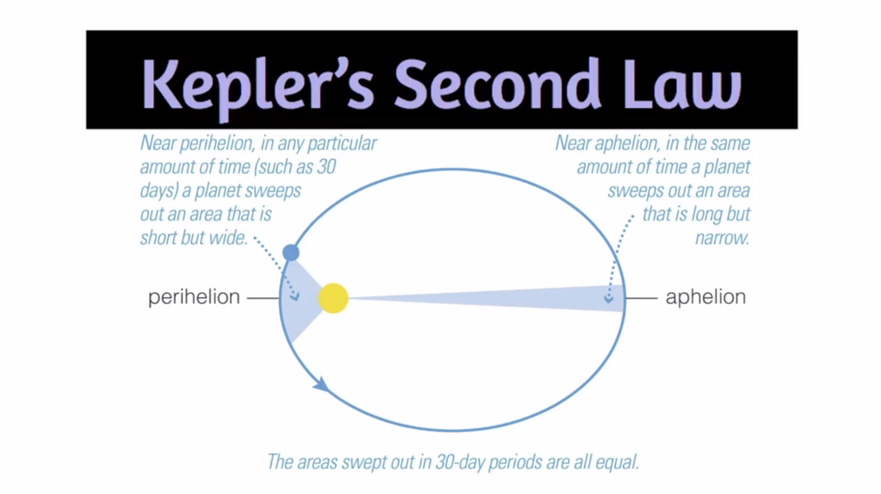

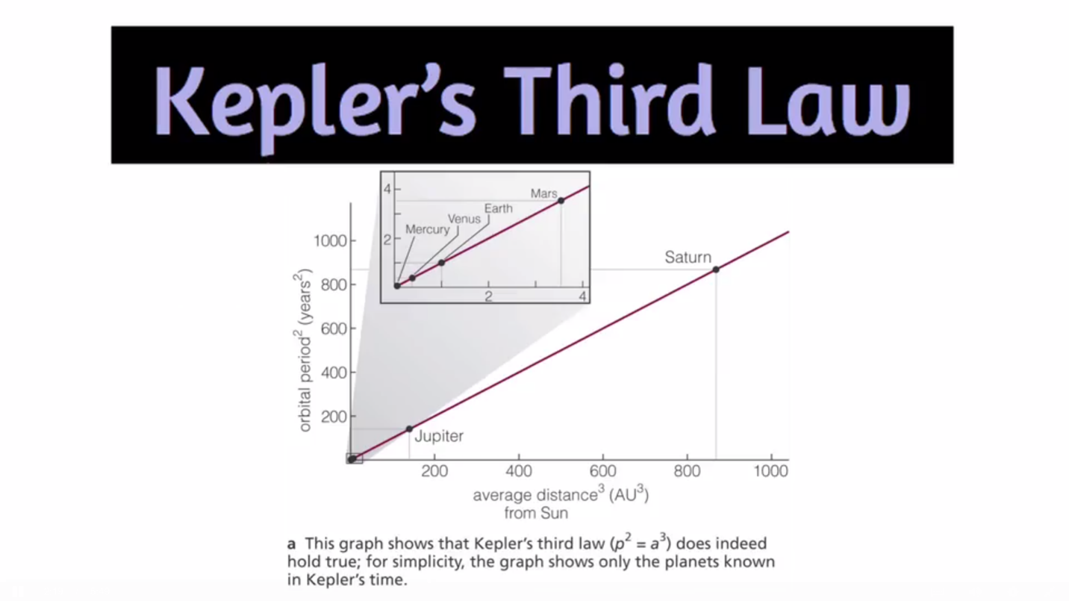

1. And now probably one of the biggest figure in the history of science: **Galileo Galilei………**

* As Galileo approached his study of astronomy, he was aware of three objections to the Copernican model rooted in Aristotelian physics. **The first** **was the objection** to the Earth being in motion because no motion is apparent even though we should all be moving at hundreds of miles an hour as the Earth spins on its orbit once a day. **The second objection** is based on the perfection of circles and spheres and the fact that imperfections in the heaven would not be countenance in the Greek view of the cosmos. **The third objection** relates to stellar power lacks. If the Earth is suddenly in motion, then why do the stars not appear to change their brightness and relative positions or angles as the earth goes around the sun?
* Galileo overcame the first objection by coming up with a precursor of the modern physical idea of inertia. The idea that the Earth as it spins and rotates carries it's atmosphere with it. So for someone standing on its surface, the large motion of rotation is not felt.
* The second objection to the heliocentric model was rooted in the Greek idea that spheres and circles represented perfection. And so, it should apply to the celestial realm. But Galileo showed with his telescope that the sun was imperfect. That is had sun spots. He was also able to show by the differential rotation of the sun that it could not be a solid object.
* The third objection to the heliocentric model was a lack of stellar parallax, the brightening and dimming of a star, or the change in the angle between stars as the Earth moves in its orbit of the sun. This had never been observed with a telescope. And even Galileo could not observe it. Stellar parallax of even the nearest star was not first detected until 1824. But what Galileo could do with his simple telescope was resolve the milky gauze of the Milky Way in to the pinpoint light of thousands or millions of stars. And he could calculate that the difference between the brightest and faintest stars he could see in the night sky was factors of hundreds of thousands, perhaps millions. And given the way light diminishes in intensity with distance from a source by the inverse square of the distance that implied a difference in distance of the brightest and faintest stars, assuming they're the same kind of star of a factor of thousands. So Galileo's observations literally gave three dimensional depth to the universe, and convinced him that we lived in a huge three dimensional universe with the stars at enormous distances. However, the clenching observation for the Copernican model was the observation of the phases of Venus.

1. However due to his views against the Church, Galileo faced many threats from the church and the church warned him not to teach his heliocentric model of the universe or else he would be executed. But Galileo was resilient, and therefore he was put under house arrest in Venice for 15 years. The final page in the Galileo's saga with the Church took a while to unfold. It wasn't until 1824, the same year that stellar parallax was first observed, that Galileo's book was removed from the ban list. And since the church moves in strange, and slow, and mysterious ways. It wasn't until 1992 that Pope John Paul the 2nd actually pardoned Galileo for the heresy of being right about the solar system.

***“The Copernican Revolution potentially has two other steps to play out. One, would be the demonstration that life on earth is not unique, that we live in a biological universe. And the other from a frontier idea in cosmology, is the idea that the entirety of space and time, visible to the limits of our telescopes, is not the totality of space and time, that there are other universes out there. Galileo cements the Copernican revolution with his observation of the phases of Venus with his small telescope. But that's not all, he also shows that the physical universe is three dimensional. With vast distances between the stars. He shows that the moons of Jupiter orbit Jupiter and that there are other worlds in space. The beginning of the idea that not only is the Earth not unique, but there might be life on other worlds. There's pushback against Galileo's ideas and he comes into conflict with the church, but by the end of Galileo's life the idea of the Earth as part of a much larger universe than the Greeks ever imagined has taken root.”***

***